**Jointly Developed**

We work with parents to develop the School-Parent compact that reflects our School Improvement Plan goals and expectations for student learning.

Description: j0332680

**Knightdale Elementary School  
School/Parent  
5th Grade Compact**

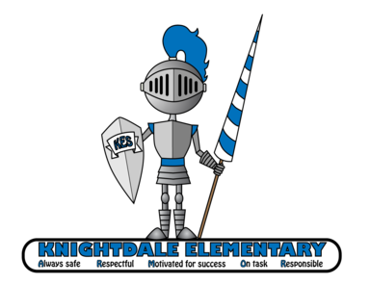

**A**lways safe

**R**espectful

**M**otivated for success

**O**n task

**R**esponsible

**Activities to Build Partnerships**

-Participation in School-Sponsored Curriculum Nights throughout the school year.

-Schedule and attend parent/teacher conferences.

-Encourage parent volunteering for classroom activities and special events.

**Communication about Student Learning**

-Parent communication letters and MClass Home Connect letters.

-Interim Reports sent home mid-way through each quarter.

-Report Cards sent home at the end of every 9 weeks.

# **What is a Family-School Compact?**

A Family-School Compact is an agreement between parents, students and teachers. It explains how parents and teachers will work together to make sure all students get the individual support they need to reach and exceed grade level standards.

## **Literacy “Big Ideas”**

* Summarizing the key details of stories, dramas, poems, and nonfiction materials
* Writing and reporting on opinions with a logical sequence of ideas and sufficient facts and details
* Identifying and judging information that supports particular ideas in an author’s argument
* Citing evidence from the text says to support reasoning.
* Identifying types of figurative language to support understanding of a text.

## **Math “Big Ideas”**

* Adding and subtracting fractions with unlike denominators and solving word problems
* Multiplying and dividing fractions and solving related word problems
* Generalizing the place-value system to include decimals
* Multiplying whole numbers quickly and accurately and dividing whole numbers
* Understanding the concept of volume, and solving word problems that involve volume.

**Students**

• Complete my homework.

• Observe school rules and procedures (ARMOR).

• Read independently for at least 20 minutes every night.

• Be at school on time and regularly.

• Participate in classroom activities.

• Ask questions when I need help.

• Be responsible with my books and school supplies.

• Be responsible for my actions and behavior each day.

• Be respectful to all teachers, staff members and fellow students.

**At Home**

**As a parent, I promise to…**

-Hold my child accountable for completing home assignments

-Provide encouragement & positive reinforcement

-Attend school events &   
parent-teacher conferences.

-Ensure that my child attends school regularly and arrives on time every day.

**In The Classroom**

**As your child’s teacher, I promise to…**

## -Provide open communication through conferences, phone calls and/or notes.

## -Collaborate with Title 1 Teachers & specialists at KES to ensure that every child receives individualized instruction.

## -Plan meaningful lessons that relate to Common Core Essential Standards.

## -Participate in school events such as Literacy Night/Math Night to support parents and students.

**Our Goals for Student Achievement**

**Teachers, Parents, Students – Together for Success**