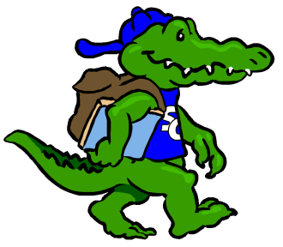
Sycamore Creek Elementary
Staff Profile
Name: Jessica Hoover |  | Grade: 1st
Favorite Color? | Mint
Favorite Flower? | Cherry Blossoms, white Dendrobium Orchids
Favorite Food? | Chicken Wings
Favorite Fruit? | Strawberries, Bananas
Favorite Drink? | Dunkin Donuts Iced Coffee, Liptons green tea (bottles)
Favorite Dessert? | Chocolate Cheesecake
Do you like Candy? (What kind?) | Ghirardelli Dark Chocolate Sea Salt Caramel  Dark Chocolate Reese’s PB cups
Favorite Restaurant? | Which Which, BJ’s Restaurant
Favorite Store? | TJ Maxx, Ulta, Target, Pier 1
If you could receive a gift card, what store would you like? | TJ Maxx, Ulta, Target, Pier 1, Amazon
Hobbies? | Photography, going to fun things in Raleigh
Things you like? | LOVE the Steelers, UNC
Any dislikes? | Cleveland Browns, Baltimore Ravens

Items Needed for Our Classroom
Dojo store items (little toys) |  | Post-it notes
Stuffed animals for our Classroom Library

