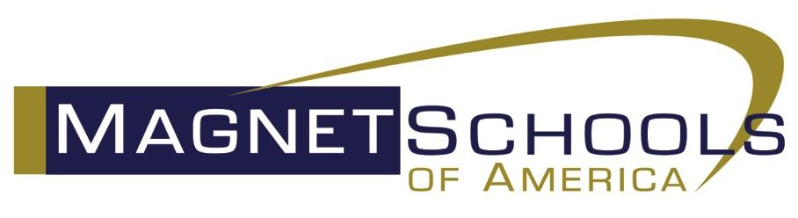

FOR IMMEDIATE RELEASE:

**Wake STEM Early College High School Named National Magnet School of Distinction by Magnet Schools of America**

**Tuesday, January 28, 2020**

**Wake STEM Early College High School** has been named a National Magnet School of Distinction by Magnet Schools of America, the national association for magnet and theme-based schools.

Presentation of Distinction Award:

**Our principal** will be recognized and receive a National Magnet School of Distinction Merit Award on behalf of the school during an awards ceremony held at Magnet Schools of America’s 38th National Conference hosted by Clark County School District in Clark County, Nevada, April 13-17, 2020.

To receive a national merit award, members of Magnet Schools of America must submit a detailed application that is scored by a panel of educators. These schools are judged and scored on their demonstrated ability to raise student academic achievement, promote racial and socioeconomic diversity, provide integrated curricula and instruction, and create strong family and community partnerships that enhance the school’s magnet theme.

To learn more about the national merit awards program, please visit [www.magnet.edu](http://www.magnet.edu)