Name_____________________________________________________ Period: __________

Represent each of the following as an algebraic inequality.

1) x is at most 30 ___________________

2) the sum of 5x and 2x is at least 14 ___________________

3) the product of x and y is less than or equal to 4 ___________________

4) 5 less than a number y is under 20 ___________________

1st: Read carefully and underline key words
2nd: Write a let statement
3rd: Determine whether to use <, ≤, >, or ≥
4th: Write and solve the inequality

5) If 5 times a number is increased by 4, the result is at least 19. Find the least possible number that satisfies these conditions.

6) The sum of twice a number and 5 is at most 15. What are the possible values for the number?

7) The cost of a gallon of orange juice is $3.50. What is the maximum number of containers you can buy for $15?

8) Three times a number increased by 8 is no more than the number decreased by 4. Find the number.

9) Two-thirds of a number plus 5 is greater than 12. Find the number.

Inequality Word Problem Homework Name_________________________________
Integrated Algebra

_____1) In order to be admitted for a certain ride at an amusement park, a child must be greater than or equal to 36 inches tall and less than 48 inches tall. Which graph represents these conditions?

_____2) Which statement is modeled by 2p + 5 < 11?
- The sum of 5 and 2 times p is at least 11.
- Five added to the product of 2 and p is less than 11.
- Two times p plus 5 is at most 11.
- The product of 2 and p added to 5 is 11.

_____3) Which is NOT a solution of the inequality 5 2x 3?
(1) 0 (2) 2 (3) 4 (4) 5

_____4) Which statement can be modeled by x + 3 12?
- Sam has 3 bottles of water. Together, Sam and Dave have at most 12 bottles of water.
- Jennie sold 3 cookbooks. To earn a prize, Jennie must sell at least 12 cookbooks.
- Peter has 2 baseball hats. Peter and his brothers have fewer than 12 baseball hats.
- Kathy swam 3 laps in the pool this week. She must swim more than 12 laps.

5) The sum of a number and 81 is greater than the product of 3 and that number. What are the possible values for the number?

6) Four times a number is greater than 48. What are the possible values for the number?

Recall four steps to help solve these types of problems:
- Read carefully and underline key words
- Write a Let statement [e.g. let x = …]
- Determined whether to use the =, >, <, sign
- Write and solve the inequality

- The quotient of a number and 15 is no greater than 450. What are the possible values for the number?

- Keith and Michelle went out to dinner. The total cost of the meal, including the tip, came to $53.70. If the combined tip came out to $9.60, and each friend spent an equal amount, how much did each friend pay not including the tip?

- Jason is saving up to buy a digital camera that costs $490. So far, he saved $175. He would like to buy the camera 3 weeks from now. What is the equation used to represent how much he must save every week to have enough money to purchase the camera?

- Adrian works in New York City and makes $42 per hour. She works in an office and must get her suit dry cleaned everyday for $75. If she wants to make more than $260 a day, at least how many hours must she work?

- Your brother has $2,000 saved for a vacation. His airplane ticket is $637. Write and solve an inequality to find out how much he can spend for everything else.

- Your local bank offers free checking for accounts with a balance of at least $500. Suppose you have a balance of $516.46 and you write a check for $31.96. How much do you need to deposit to avoid being charged a service fee?

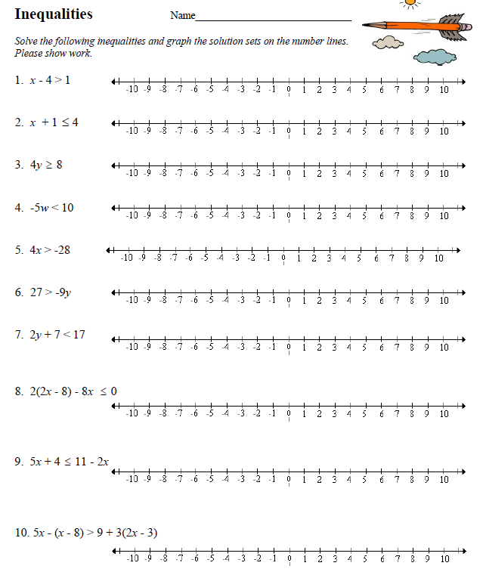

Solving Inequalities is the same as solving an equation. You use the same steps as equations, but the only difference is if you multiply or divide by a negative number you must FLIP the inequality sign so the opening goes the other way.

Remember: When you graph the answer to the inequality, if the sign is < or > the circle is not shaded and if the sign is
or
the circle is shaded.

Steps for solving equations:

- Remove all parentheses by using the distributive property.
- Combine like terms that occur on the same side of the equations.
- Perform +/-
- Perform /

Review Sheet
1) | 2) | 3) Write an inequality to represent: Ten is no more than four less than a number.
4) Does x = -3 satisfy the inequality 2x – 4 < -12? | 5) Is n = 3 a solution for the inequality n(n – 6) > -4 ? | 6) Translate the verbal expression into an algebraic inequality, solve an graph your answer:  The sum of twice a number and 5 is at most 3 less than a number.

