CHARACTERISTICS OF FANTASY AND FUTURISTIC FICTION
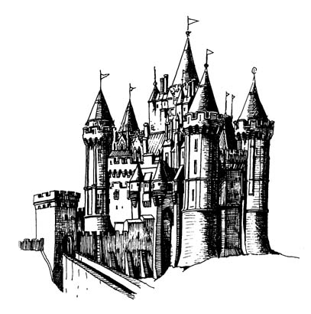

FANTASY - contains elements that are not realistic
- talking animals
- magical powers
- often set in a medieval universe
- possibly involving mythical beings

The key element of the fantasy fiction genre is magic. Fantasy novels may be romantic, historical, action-packed or all three, but the element of magic is what sets this genre apart from all the others. Fairy tales, myths, and legends are part of the fantasy genre. Stories featuring wizards and sorcery, unicorns and dragons, are fantasy. Through fantasy fiction, readers are allowed to visit a world they never would have been able to otherwise.

Although all fantasy stories are unique, there are some characteristics that are common of the genre. In general, the conflict in fantasy novels is of good versus evil. Usually, the protagonist and supporting characters set out to conquer this evil, although this is often played out through a series of books, rather than just one. Most fantasy fiction also features great details, with settings, creatures, words and names that are often created by the author. Fantasy novels must be read carefully, for their settings and characters are not familiar in everyday life.

Supernatural Creatures: Elves, dragons, dwarves, enchanted plants, vampires, werewolves and talking animals. The right combination of these, alongside a few lowly humans, creates an essential dynamic between the real and the surreal.

Magic, or a lack thereof. Characters have to be able to perform some form of magic. Most often the hero or heroine possesses a very strong magical ability that they don’t initially have, or don’t know they have, and learn to develop.

Love: Although the love factor must remain on the PG-rated side, a love interest exists in order to pull at the heart strings of readers. Usually the love interest of the main character is unattainable. It helps if they are not of the same genetic make-up (i.e. Human and Vampire, Human and Elf, Werewolf and Vampire, etc.)

The Villain: The Villain must be extraordinary and not easily defeated. The villain is often not revealed in person until the end of the story, in order to create the most impact.
A Great Battle: Without an epic battle in which the hero is nearly defeated, ultimate victory would not be so sweet.

The Weapon: Harry Potter has his wand, Eragon has his sword and Bella has her ability to hide her mind from others. Whatever the weapon, it has to be special in not only its capabilities, but also in the reason behind its existence.

The Setting: From Middle-earth, to Narnia, Alagaesia, Hogwarts, and even Forks, the setting is another character in the story. It is the unique quality of the landscape that allows for most of the events in the story to take place.

Language: Whether it’s a fabricated language, such as the Elvish speak in Tolkien’s works, or it’s the manipulation of how an existing language is spoken, common vernacular won’t do. The inclusion of a fantasy language heightens the reader’s ability to transport themselves into a different world.

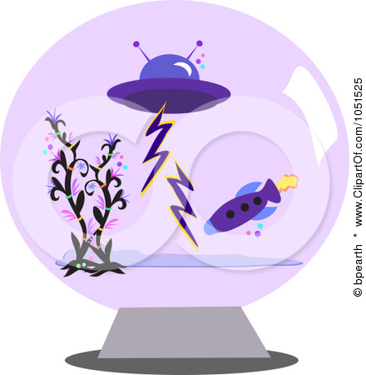
SCIENCE FICTION (Sci Fi)- stories that often tell about science and technology of the future involving partially true fictions laws or theories of science

Settings:
- in the future
- in space
- on a different world
- in a different universe or dimension

Aliens
Aliens are one of the central characteristics of the science-fiction genre. A sci-fi novel may deal with aliens coming to Earth, humans encountering aliens on space explorations or a number of other variations. Sometimes the aliens are friendly, while other works portray aliens as mortal enemies.

Space Travel
Space travel is a common element of sci-fi, regardless of whether or not it features contact with aliens. Space travel pops up in fiction over and over again as humans wonder whether or not they're alone in the universe, and what might happen if humans encounter other life forms.

Time Travel
In scientific theory, time travel is possible based on potential technologies utilizing scientific knowledge. In fiction, time travel poses many questions, including that of the time travel paradox, and it is a popular topic for science fiction, as protagonists can glimpse the future or change events in the past.

Futuristic Setting or Alternate History
Even if there's no time travel involved, science fiction novels are often placed in a futuristic setting, while other sci-fi novels feature alternate histories. Whether moving forward or back in time, very few sci-fi novels are set in the present day.

Advanced Technology
Early science fiction writers and editors focused on the hard science of science fiction, and much of that incorporates the development of advanced technology, or creative ways to utilize existing technology. As the last century has seen big advances in technology, it's not difficult to imagine some traditional sci-fi technology that could be very real in the future.

Additionally, some science fiction writers have proven almost prophetic in predicting the rise of technology that didn't exist during their time-notably Jules Verne, although other writers have foreshadowed or outright predicted other pieces of technology.

Dystopia
One common theme of many science fiction novels is a dystopia set sometime in the future. Dystopia sci-fi themes are often used to explore current social issues, and they have very little to do with science, except dystopian fiction that revolves around technological mis-utilization. "Nineteen Eighty-Four" is a good example of a dystopian sci-fi story.

Exploration Of Popular Societal Or Cultural Issues
Much of sci-fi attempts to explore popular societal or cultural issues through a sci-fi setting. These issues range from class struggles to misuse of technology, and sci-fi gives voice to the concerns of the society in which they are conceived. Common social issues include a world destroyed by war; a world destroyed by overuse; a world in which the government controls everything; or a world in which genetic experimentation has gone terribly awry.

