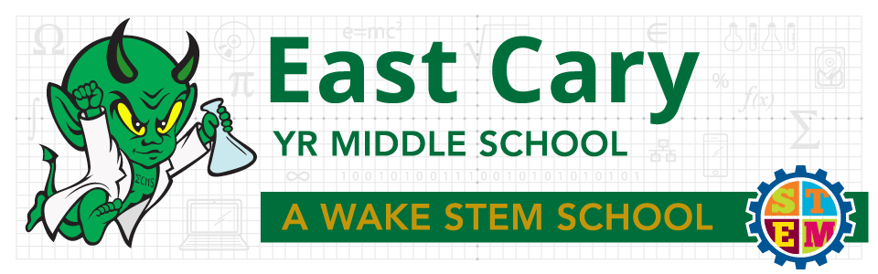
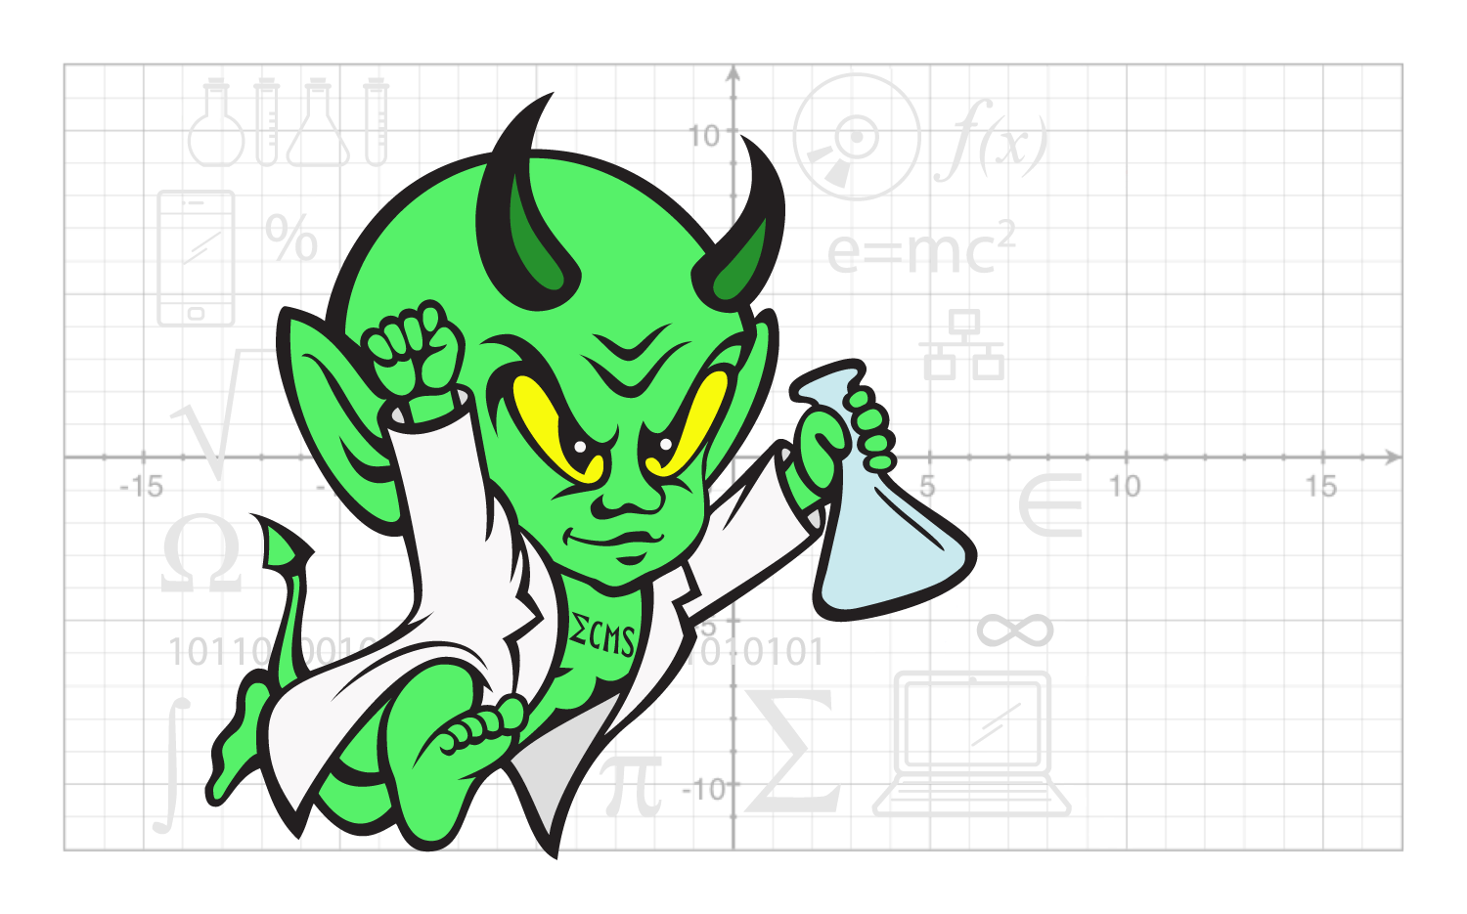
East Cary Middle School
SIP Committee Meeting
Monday, September 19th, 2016
2:30-3:30pm * Media Center
[Type a quote from the document or the summary of an interesting point. You can position the text box anywhere in the document. Use the Drawing Tools tab to change the formatting of the pull quote text box.]

Representatives Present:
6-1: L. Haynie 7-1: Tracked Out 8-1: Tracked Out
6-2: H. Ledford 8-2: S. El Shafie 7-3/8-3: T. Hackman
8-4: C. Holmes 6-4: L. Graham 7-4: T. Mattson
SPED: Absent PE: M. Smith Arts: M. Arnstein
Admin: S. Ellis, S. Spruill, N. Davis
IRT: J. Ethridge
Student Services: M. Ray-Nobles
Media/Tech: D. Harris
Parent Reps: Absent (tracked out)
What | Who | How | Time
Set-up  - Norms/Roles  - Desired Outcomes  - Agenda | L. Haynie | - Present  - Clarify  - Check for agreement | 2 minutes
Norms, outcomes and agenda reviewed.

Finish Future Protocol of Walkthrough Instruments | L. Haynie | - Small groups  - Finish conversations about what walkthroughs would look like at ECMS by 2018.  - Share Out | 10 minutes
Small groups reviewed and finished up their conversations started at the last meeting about what walkthroughs at ECMS should look like by 2018. Thoughts from small groups were shared out with the large group.

Non-Negotiables and the Three Focus Categories | N. Davis | - Davis to present non-negotiables (things to be seen in every classroom no matter the time visited).  - Discussion of the Three Focus Categories of a walkthrough.  - Sorting activity of the non-negotiables.  - Share Out | 15 minutes
Ms. Davis reviewed the “non-negotiables” that should be seen in every classroom no matter the content area or the time visited. These “non-negotiables” include:
- Essential Questions posted in kid-friendly terms; students should know why they are learning and completing activities/assignments.
- Level of student engagement (active vs. passive)
- Culture of collaboration
- Level of Questions based on Revised Bloom’s Taxonomy
- Teacher movement
- Technology integration
- Evidence of the 4C’s
These will be added to our classroom walkthrough instrument in some form or fashion.

Ms. Davis also talked about how a walkthrough instrument is based on three areas of focus: 1) Focus on Learners & Relevance, 2) Focus on Instruction & Rigor, and 3) Focus on Environment and Culture. These three areas of focus can be seen on the sample walkthrough given to SIT members in the next portion of the agenda.

Sorting Activity was skipped based on time. SIT moved on to the next agenda item.

Feedback on a Sample Walkthrough Instrument | N. Davis/L. Haynie | - Small groups  - See projector screen for directions.  - One walkthrough paper from each group will be submitted to Haynie as feedback.  - Share Out (if time allows) | 30 minutes
SIT members worked in three groups to provide feedback on the sample walkthrough given. One group provided feedback on the Learner & Relevance section, one group gave feedback on the Instruction & Rigor section, and the last group gave feedback on the Environment & Culture section. SIT members used the following guiding questions to examine the sample feedback:

Sample Walkthrough Feedback Protocol
- (*) Star what already goes on at ECMS.
- Highlight the areas that your group believes can be placed on our ECMS walkthrough based on the guiding questions below.
- (?) Place a question mark for any areas in which you have questions, jot the question next to the strategy or in the notes section.
Guiding Questions
Based on the WCPSS Vision 2020 and the ECMS SIP,
- What is valued?
- What do we want to see?
- How do the non-negotiables align?
Please see the PDF link for the feedback given from various groups: Sample Walkthrough Feedback
*If the link does not work, please see the PDF attached to the SIP Minutes e-mail.

Next Steps  Next Meeting:  Monday, October 17th, 2016 | L. Haynie | - Discussion of committees and action steps needed to be completed by SIT members to prepare for the 1st Quarterly review in November.  - Changes to the SIP are coming due to change in legislation. | 3 minutes
- The next step in our walkthrough instrument creation will be completed which includes looking at a sample walkthrough for ECMS.
- SIT members will be divided into two committees based on the two Key Processes in our SIP. A list of action steps will be given to each committee to be completed prior to the November meeting which will be ECMS’ 1st Quarterly Review.
- Updated information will be given about legislation changes in regards to AMO subgroups due to ‘No Child Left Behind’ going away and ESSA coming beginning in 2017-2018.

By June 2018, East Cary Middle School will meet or exceed expected growth by increasing proficiency from 74.4% to 76.0% in reading and math as reported by EVAAS with a focus on Hispanic, Black, and SWD subgroups meeting AMO targets as measured by EOG/C scores.

