East Cary Middle School
SIP Committee Meeting
Monday, February 29th, 2016
2:30-3:30pm * Media Center
[Type a quote from the document or the summary of an interesting point. You can position the text box anywhere in the document. Use the Drawing Tools tab to change the formatting of the pull quote text box.]

Representatives Present:
6-1: L. Haynie 7-1: Greene 8-1: Absent
6-2: Tracked Out 7-2: Tracked Out 8-2: Tracked out
6-3: G. Radbill 7-3/8-3: T. Hackman 8-4: Absent
6-4: E. Speaks 7-4: Absent SPED: Monroe
CTE: Absent PE: Absent Arts: Landry
Admin: N. Davis, S. Ellis, S. Spruill
IRT: Stern
Student Services: M. Ray-Nobles
Media/Tech: Tracked Out
Parent Reps: Absent
What | Who | How | Time
Set-up  - Norms/Roles  - Desired Outcomes  - Agenda | E. Speaks | - Present  - Clarify  - Check for agreement | 5 minutes
Norms, outcomes and agenda reviewed.

Review of Previous Steps in SIP Process | L. Haynie | - Present  - Clarify  - Check for agreement | 5 minutes
SIP Process up until this point was reviewed.

Gallery Walk Through a Different Lens | L. Haynie/E. Speaks/N. Davis | - Obtain a stakeholder description.  - Re-examine our action steps through your stakeholder’s lens.  - Use Gallery Walk Protocol (see directions on projector screen)  - Share Out | 60 minutes
Each SIT member was given a different stakeholder’s persona. Members read their stakeholder’s profile aloud and there were challenged to look at the work the SIT team has done this year through their lens/point-of-view. Members were asked to do a Gallery Walk examining proposed Action Steps and make comments on each Action Step through their stakeholder’s lens. Members either had to:

As you walk through our gallery, you will do 1 of 3 things using your specific marker color.
  - Write an “!” on the poster if you are “For It!”
  - Write a “check mark” if you “Agree”.
  - Write a “?” if you still have questions. Please also write your question on a sticky note and attach to the poster.
You can also add another action step directly on the poster.
Picture Examples
See Next Page
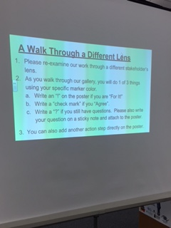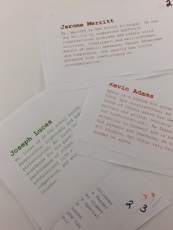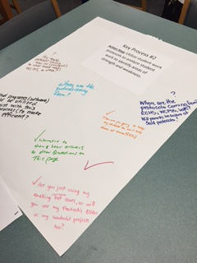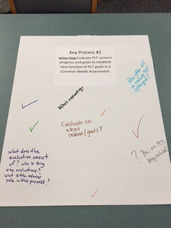

Next Steps  Next Meeting:  Monday, March 21st, 2016 | L. Haynie/E. Speaks | - Next meeting: Continue work on our upcoming Comprehensive Needs Assessment (CNA). We have already made some steps towards this through our SIP process this year.  - Alignment with WCPSS Strategic Plan: Vision 2020 | 5 minutes
Discussion about the work of completing our Comprehensive Needs Assessment was discussed. Administration and Haynie is getting more information about completing this document. Most of the work SIT has done this year has been towards developing our 2016-2018 plan which aligns with our CAN.

Also, all school SIPs will align with the WCPSS Strategic Plan: Vision 2020. All schools will adopt the WCPSS Mission and Core Beliefs. ECMS may use own Vision and Values. These will be adopted during the re-write. We will review our current ECMS Vision and Values in a future meeting.

By June 2016, East Cary Middle School will meet or exceed expected growth in reading and math as reported by EVAAS with a focus on Hispanic, Black, and SWD subgroups meeting AMO targets as measured by EOG/EOC scores.

