East Cary Middle School
SIP Committee Meeting
Monday, August 15th, 2016
2:30-3:30pm * Media Center
[Type a quote from the document or the summary of an interesting point. You can position the text box anywhere in the document. Use the Drawing Tools tab to change the formatting of the pull quote text box.]

Representatives Present:
6-1: L. Haynie 7-1: S. Greene 8-1: J. Duprey
6-2: H. Ledford 8-2: S. El Shafie 7-3/8-3: Tracked Out
8-4: C. Holmes 6-4: L. Graham 7-4: T. Mattson
SPED: K. Cole-Brown PE: M. Smith Arts: M. Arnstein
Admin: S. Ellis, S. Spruill, N. Davis
IRT: J. Ethridge
Student Services: M. Ray-Nobles
Media/Tech: D. Harris
Parent Reps: G. Gaines, A. Kirk, P. Kariuki
District Rep: J. Herbst
What | Who | How | Time
Set-up  - Norms/Roles  - Desired Outcomes  - Agenda | L. Haynie | - Present  - Clarify  - Check for agreement | 2 minutes
Norms, outcomes and agenda reviewed.

Modifications to 2016-2018 | L. Haynie | - Present  - Clarify  - Check for agreement | 5 minutes
Modifications/adjustments made to the SIP plan based on the 2015 EOG/C data was shared. The modifications will be shared with the rest of the staff soon and will be voted on once again.

Purpose of Walkthrough Instruments | N. Davis/L. Haynie | - Review Future Protocol Input (15-16)  - Small groups, jigsaw activity  - Notes/comments from each group placed on chart paper based on selected article/video  - Share Out | 30 minutes
SIT members were divided into four groups. Each group was responsible for reviewing either an article or a video. Groups wrote the highlights/main ideas from their respective resource.

The resources used:
Group 1 - Article: "Using Classroom Walkthroughs to Improve Instruction"

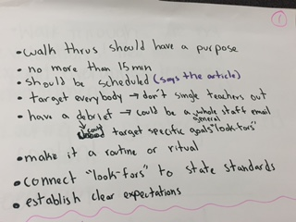

Group 2 - Article: "Classroom Walkthroughs: Learning to see the trees and the forest"

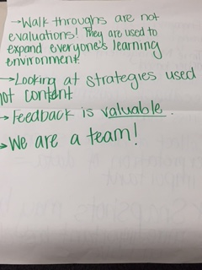

Group 3 - Video: "Teacher Walkthroughs"
*Picture on next page
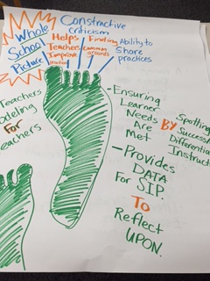

Group 4 - Video: "What NOT to do in a Classroom Walkthrough"

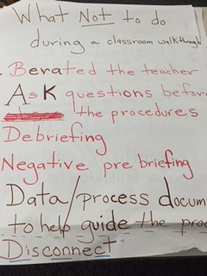

Future Protocol of Walkthrough Instruments | N. Davis/L. Haynie | - Small groups  - Begin conversations about what walkthroughs would look like at ECMS by 2018. | 20 minutes
Discussion began about what classroom walkthroughs should look like at ECMS by June 2018. The conversation will be continued at the next meeting.

Next Steps  Next Meeting:  Monday, September 19th, 2016 | L. Haynie | - Vote on new school goal and 2016-2017 SIT members with whole staff.  - Create our walkthrough instrument to help monitor our progress towards our goal. | 3 minutes
- The ECMS staff will need to vote on the updated SIP, as well as, vote on the SIP team members for the 2016-2017 school year.
- SIT members will need to discuss with their respective teams/departments about what classroom walkthroughs should look like at ECMS. SIT members are to report back at the next meeting.
- Continue our conversation about classroom walkthroughs – elements to be included, type of tool, etc.

By June 2018, East Cary Middle School will meet or exceed expected growth by increasing proficiency from 74.4% to 76.0% in reading and math as reported by EVAAS with a focus on Hispanic, Black, and SWD subgroups meeting AMO targets as measured by EOG/C scores.

