**DAILY ANNOUNCEMENTS BULLETIN** 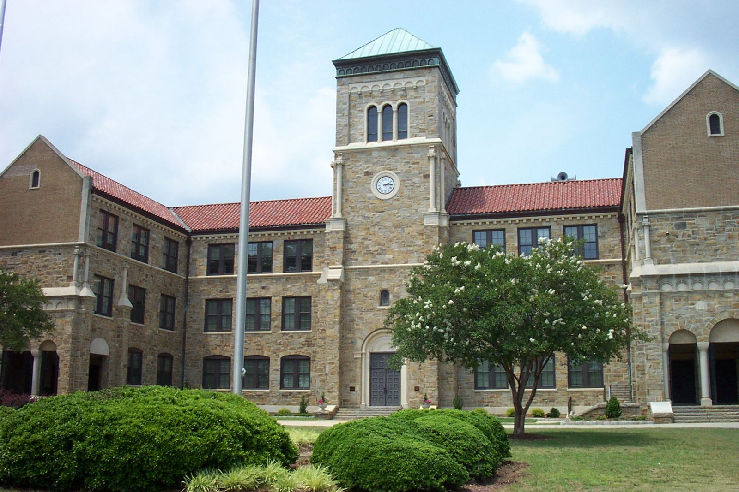

**Wednesday, September 11, 2024**

**A-Day**

**Advisory Bell Schedule**

**TODAY’S EVENTS**

**MOMENT OF SILENCE, 7:25**

**Rep from Virginia Commonwealth @ BHS, 8:00am**

**Junior Class Meetings During English Classes, Diane Payne Auditorium**

**Advisory Class, 8:55-9:25**

**JV Girls Tennis vs Cardinal Gibbons @ Cardinal Gibbons High, 3:30pm**

**Varsity Girls Tennis vs Cardinal Gibbons @ BHS, 3:30pm**

**FYI: The Daily Announcements Bulletin [DAB] is posted on Broughton Magnet High School Homepage. Visit** [**https://www.wcpss.net/broughtonhs**](https://www.wcpss.net/broughtonhs) **, or use the QR code below:**

**DABs Scholarship Bulletins College Rep Visits**



|  |
| --- |
|  |
| **PARENT ANNOUNCEMENTS**  The Broughton High School Pantry supports our students and staff and families who need food, clothing, toiletries, household items and school supplies. Students with needs are identified by teachers and counselors. The pantry is open every Monday and Thursday from 6:55-7:25 am and 2:15-2:45 pm. This outreach activity is supported through donations from students, staff, families and interfaith outreach organizations. We will be doing pantry collections throughout the year as needed so watch your class emails for the list of needed items. In addition, we welcome financial donations at any time; funds donated will be used to purchase needed items throughout the school year. Checks should be written to: Broughton Food Pantry and mailed to Broughton Food Pantry, ATTN: Betsy Graves or Chris Bates, 723 St. Mary’s Street, Raleigh NC 27605. |

Here is the weekly message for our families

**Important Dates**

**September 20: Teacher Workday [no school]**

**September 30-October 4: Homecoming Week**

**October 14: Teacher Workday [no school]**

**October 31: End of Quarter 1**

**November 1: Teacher Workday [no school]**

**November 5: Election Day [no school]**

**November 11: Veterans Day Holiday [no school]**

**November 27-29: Thanksgiving Break [no school]**

**December 23-January 2: Winter Break [no school]**

**January 20: Martin Luther King Jr Holiday [no school]**

**January 21: Teach Workday [no school]**

**January 22: End of Quarter 2**

**February 7-8: Queen of Hearts Assembly & Dance**

**February 17: Presidents Day Holiday [no school]**

**March 14: Teacher Workday [no school]**

**March 31-April 7: Spring Break [no school]**

**April 8: End of Quarter 3**

**April 12: Junior Senior Prom**

**May 2: Teacher Workday [no school]**

**May 26: Memorial Day Holiday [no school]**

**June2-13: Final Exams**

**June 13: Graduation**

**STUDENT ANNOUNCEMENTS [GENERAL]**

**Deadline Dates for Yearbook:**

**Non-Senior Photo Day – September 27**

**Senior Quote Deadline – October 18**

**Yearbook ONLY Photo Day – October 25 [Sign Up Genius]**

**Make-Up Day – November 15**

**Non-Senior Portraits placed in Yearbook – January 17**

**Senior Portraits placed in Yearbook – January 31**

**Senior Ads Due – January 31**

**Yearbook Completed – March 5**

**STUDENT ANNOUNCEMENTS [JUNIORS & SENIORS]**

**Seniors:** Scholarship Bulletin #1 has been posted on our homepage and can be found by going to Students/Seniors/Scholarship Bulletins/Scholarship Information. It has also been posted on the Student Services Webpage: <https://sites.google.com/wcpss.net/bhsstudentservices/home>.

**Seniors interested in seeking a degree in education [STEM, Middle Grades, Elementary Education or Special Education]:**

For students interested in learning more about the NC State College of Education, the virtual information session offered on Wednesdays throughout the fall semester I recommended. In addition, the Open House at NC State on Saturday, October 19, is recommended.

For students interested in learning more about the Teaching Fellows Program, attending a virtual Teaching Fellows Information session on September 24, October 16,m or December 12 from 7:00-8:00pm is recommended.

**Seniors interested in East Carolina University:**

**East Carolina University [ECU]** has a number of scholarships available for incoming freshmen – some specific to geographical locations and certain high schools, some need based and some merit based and some a combination of any of these factors. ECU utilizes an on-line portal, **ECUAWard,** to accept applications for their scholarship opportunities. To complete the scholarship application, a student must have been accepted for admission, but they do not have to commit to attending ECU to apply for scholarship consideration. The scholarship application portal is open August 1-January 15 for applications for funding for the 2025-2026 academic year. Students interested in the Honors College, the scholarship deadline is December 3rd so need to apply for Admission early in the cycle. If interested, visit [honors.ecu.edu](https://honors.ecu.edu/) for the most current information.

**Seniors interested in the University of Virginia:**

**The Jefferson Scholars Foundation is now accepting nominations for the Jefferson Scholarship**. Jefferson Scholarships are awarded to high school seniors who demonstrate excellence and exceptional potential in the areas of leadership, scholarship, and engaged citizenship. Recipients receive the entire cost of attendance at UVA and many supplemental enrichment experiences – a value of more than $345,000. Broughton may nominate one student, and the deadline for tor submitting all required materials is November 15, 2024. If interested in being considered for nomination, see Dean Sauls before October 15, 2024.

**Students interested in Davidson College:**

**Broughton has been invited to submit up to two outstanding seniors for their John M. Belk Scholarship**. The scholarship covers funding [tuition, fees, food, and housing for four years, plus $6,000 in special opportunity stipends. It recognized powerful students with demonstrated academic excellence, integrity, intellectual curiosity, willingness to take risks, and potential to be change agents in both their local and global communities. Nominations are due on November 1, 2024. If interested in being considered for nomination, see Dean Sauls before October 1, 2024.

**Juniors & Seniors who are eligible for OFF-CAMPUS LUNCH PASSES should drop off their requests in the basket outside the Student Services Office.**

**College & University Reps Visiting Broughton**

**`**

**Sewanee Monday, September 16 B-Day 10:00am**

**UNC-Charlotte Monday, September 16 B-Day 8:00am**

**Highpoint University Wednesday, September 18 B-Day 9:00am**

**School of Art Institu of Chicago Wednesday, September 18 B-Day 1:00pm Room 1215**

**Christopher Newport Thursday, September 19 A-Day 8:00am**

**Wofford College Thursday, September 19 A-Day 9:00am**

**John Cabot University Thursday, September 19 A-Day 10:00am**

**Auburn University Monday, September 23 B-Day 9:00am**

**Eckerd College Tuesday, September 24 A-Day 8:00am**

**Binghampton University Tuesday, September 24 A-Day 9:00am**

**University of Georgia Thursday, September 26 A-Day 9:00am**

**Brown University Thursday, September 26 A-Day 9:45am**

**James Madison University Friday, September 27 B-Day 9:00am**

**Furman Monday, September 30 A-Day 9:00am**

**Queens Monday, September 30 A-Day 10:00am**

**Davidson College Wednesday, October 2 A-Day 8:00am**

**University of Richmond Friday, October 4 B-Day 9:00am**

**UConn Tuesday, October 15 B-Day 8:00am**

**University of Kentucky Wednesday, October 16 A-Day 8:00am**

**Oberlin Thursday, October 17 B-Day 10:00am**

**University of South Carolina Thursday, October 17 B-Day 9:00am**

**Virginia Commonwealth Univ. Wednesday, October 23 B-Day 7:30am Room 1215**

**William Peace Wednesday, October 23 B-Day 8:00am**

**Seniors and juniors may sign up to meet with college representatives who visit Broughton throughout the school year. Please sign up to attend here.**

**2025 SUMMER OPPORTUNITIES**

**[Link to the list that is posted on CFNC with summer enrichment opportunities]**

**https://www2.cfnc.org/studentEnrichment**