Code On at Home!

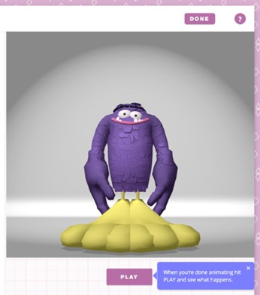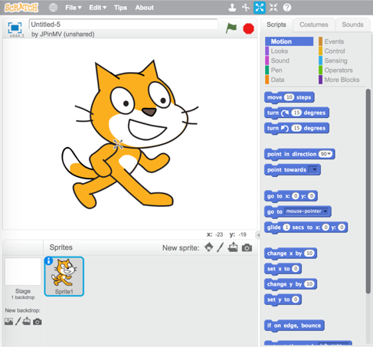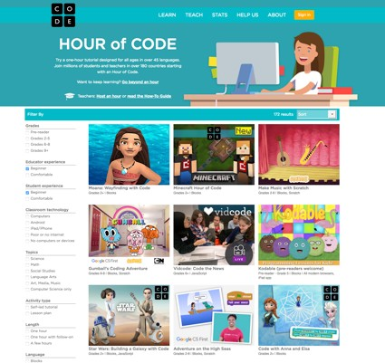

# Continue Tonight’s Program

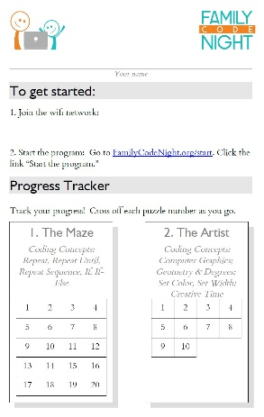

Take home your Program Card, and pick up right where you left off tonight! Start at [www.FamilyCodeNight.org/Start,](http://www.FamilyCodeNight.org/Start) click link to go to first puzzle, then navigate to your next puzzle using the line of white dots (top center of each puzzle). Finish “The Maze” puzzles, then tackle “The Artist” at [www.FamilyCodeNight.org/StartArtist.](http://www.FamilyCodeNight.org/StartArtist)

1. **Do the Other “Hours of Code”** There are lots more fun Hour of Code programs from Code.org you can do at home or at school. Play and code with

Moana, Minecraft, Star Wars, Frozen and many others. It’s great fun, and you’ll learn new coding every step of the way! Do them all! Find them at https://code.org/learn. If you like, you can create your own account – there’s always more to learn there.

# Google’s Made With Code, MIT’s Scratch

Made With Code. There’s a world of fun coding projects at Google’s Made With Code. Our favorite is “Build a Yeti” (you get to build your own big hairy dancing monster!). Find it here: https://[www.madewithcode.com/projects/animation.](http://www.madewithcode.com/projects/animation) (Click the “Projects” link, upper right, to see other fun Made With Code Projects.)

Scratch. For older kids ready for the next step, check out MIT’s Scratch programming language for kids. With Scratch, you create a free online

account at MIT, then program your own apps, games, stories, animations and more. You can even publish your creations so anyone can see and play with them. It’s all at https://scratch.mit.edu/. Click “Join” to set up your account, then explore what’s there (one way to learn: click Create, then click the “Tips” menu, upper left, to learn the basics of this great language).

# Top 10 Ways Families Can Encourage Girls’ Interest in

**Computing** (from the National Center for Women & Information Technology)

A great summary of family ideas and fun projects (good for boys too!). Find it here: https://[www.ncwit.org/resources/top-10-ways-families-can-encourage-girls-interest-computing](http://www.ncwit.org/resources/top-10-ways-families-can-encourage-girls-interest-computing)

© 2016 FamilyCodeNight.org

*Featuring Hour of Code puzzles from Code.org®*