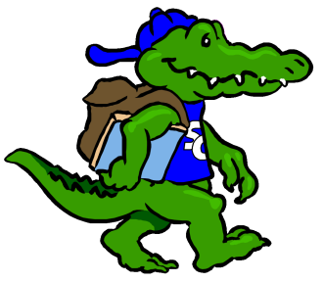
Sycamore Creek Elementary

Staff Profile
Name: Lynn Woodrow |  | Grade: Literacy
Favorite Color? | purple
Favorite Flower? | rose,daisy
Favorite Food? | chinese
Favorite Fruit? | blueberries
Favorite Drink? | coffee
Favorite Dessert? | anything chocolate
Do you like Candy? (What kind?) | anything chocolate
Favorite Restaurant? | Tazu, O’Charley’s
Favorite Store? | The Limited
If you could receive a gift card, what store would you like? | Target
Hobbies? | tennis, reading, gym
Things you like? | books, working out

Any dislikes?

Items Needed for Our Classroom

Clorox wipes!

thin dry erase markers – we use many

kleenex

colored post-its

treasure box items

