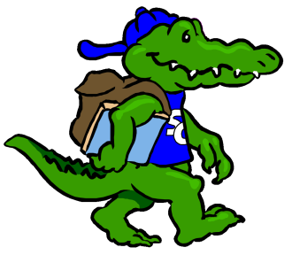Sycamore Creek Elementary

Staff Profile

|  |  |  |
| --- | --- | --- |
| Name: Nicole Walters | | Grade:1st |
| **Favorite Color?** | Green and Pink | |
| **Favorite Flower?** | Tulips | |
| **Favorite Food?** | Fresh veggies, nuts, pickles, olives | |
| **Favorite Fruit?** | Berries and bananas | |
| **Favorite Drink?** | Lemonade | |
| **Favorite Dessert?** | Chocolate cake | |
| **Do you like Candy? (What kind?)** | - | |
| **Favorite Restaurant?** | Chick-fil-A, Moe’s | |
| **Favorite Store?** | Target, Michael’s Craft Store | |
| **If you could receive a gift card, what store would you like?** | TeachersPayTeachers.com, Target, Michael’s Craft Store | |
| **Hobbies?** | Reading, running, cooking | |
| **Things you like?** | I love having cute stationary! | |
| **Any dislikes?** |  | |
| Items Needed for Our Classroom | | |
| Seasonal stickers for winter and spring time. | | Snacks for friends that forget |
|  | |  |
|  | |  |
|  | |  |
|  | |  |
|  | |  |