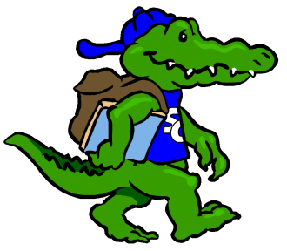
Name: Rachael Biggs |  |  | Grade: First Grade
Favorite Color? | Gold and Pink
Favorite Flower? | Tulip, Dahlia, Peonies,
Favorite Food? | Mac and Cheese and medium rare steak
Favorite Fruit? | Clementines, Fuji Apples,
Favorite Drink? | Medium/Light-roast Coffee with Creamer
Favorite Dessert? | Krispy Kreme Hot Original Glazed Doughnuts
Do you like Candy? (What kind?) | Angie’s Boom Chicka Pop Frosted Sugar Cookie Kettle Corn! Cinnamon-sugared pecans, Plain Hershey’s Kisses
Favorite Restaurant? | Metro Diner, Panera Bread, Piper’s Tavern, Crisp @ Crabtree Valley Mall, Chic-fil-A, Waffle House,
Favorite Store? | Ulta, Belk, Spartina 449 jewelry, Starbucks, Amazon
If you could receive a gift card, what store would you like? | Amazon!!!
Hobbies? | working out, decorating, drawing, painting
Things you like? | Reading with my 2 1/2 year old son, working out, take out with my husband for date night
Any dislikes?

Items Needed for Our Classroom
Plastic Spoons/Forks (when a child forgets to bring for snack) |  | Snacks (when a child is without snack that day)
Prize Box Items/Toys (Dollar Store stuff or candy!)

